HandsOn Day 1:

Java and maven installation

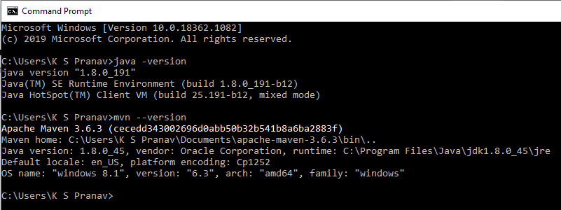

2. GitHub account : sugandevops

3. Executed SpringBoot Application and results

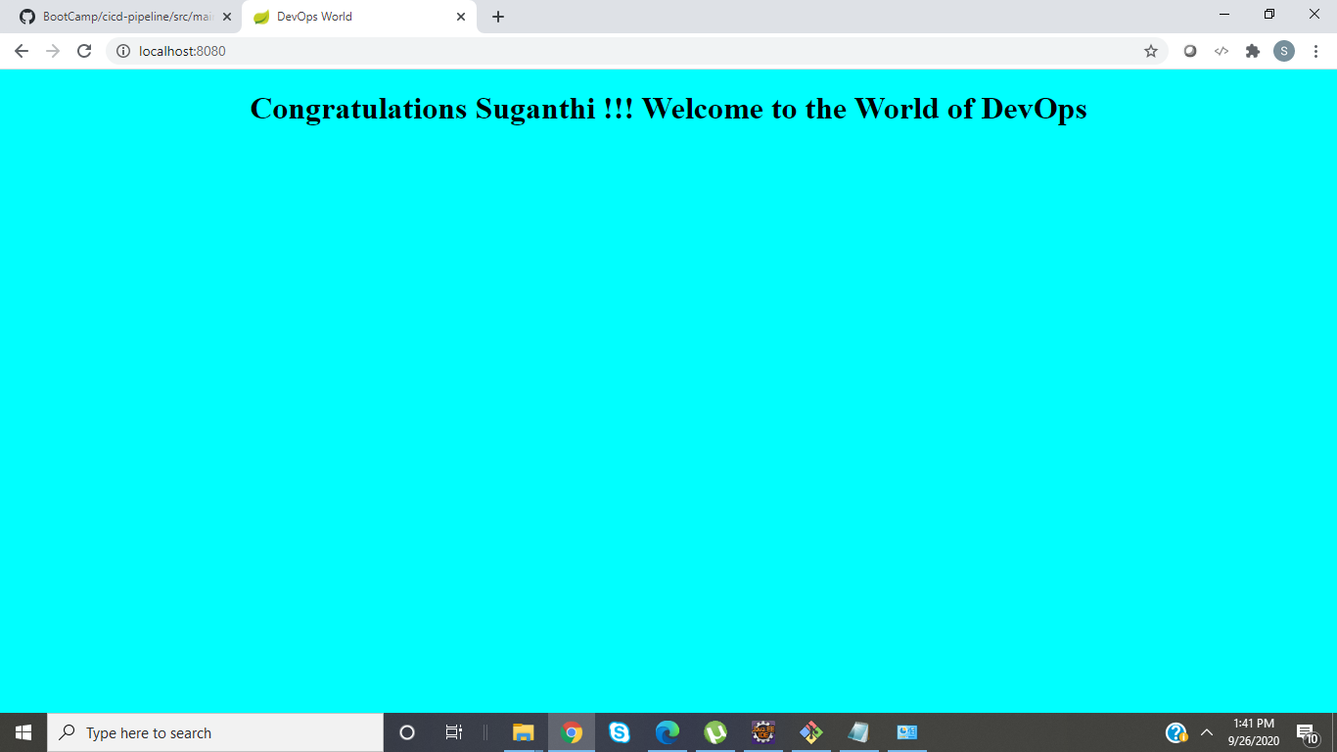

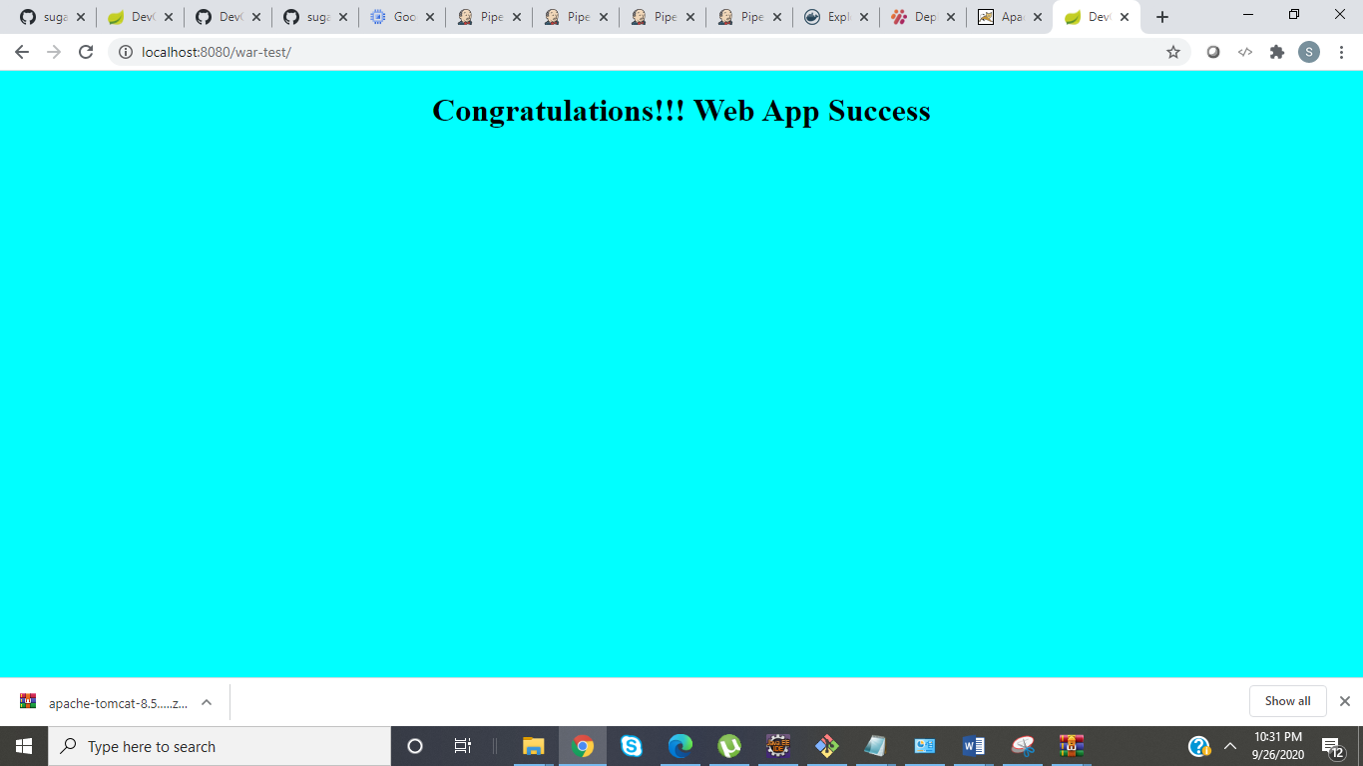

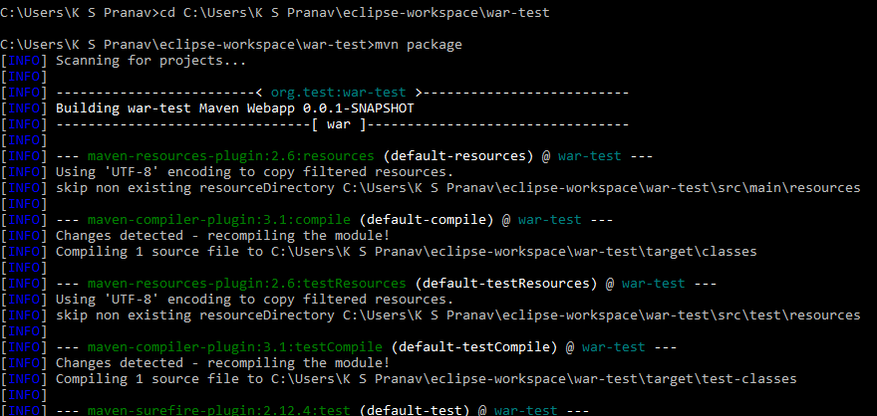

Handson Day2:

Practiced Junit test cases

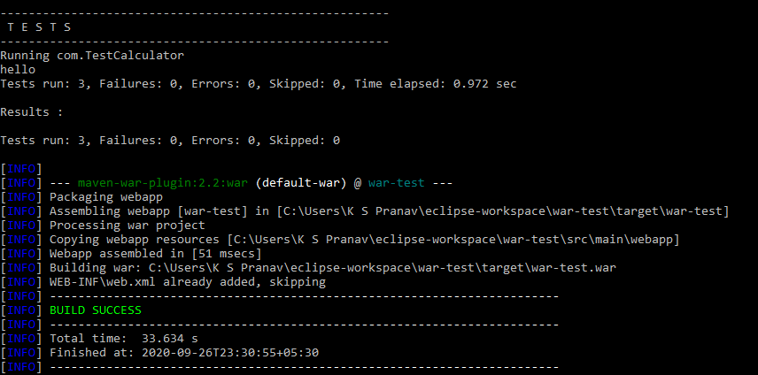

Handson Day3:

Practiced Docker commands and pushed to Repo

Dockerfile uploaded to Repo

Images pushed to dockerhub

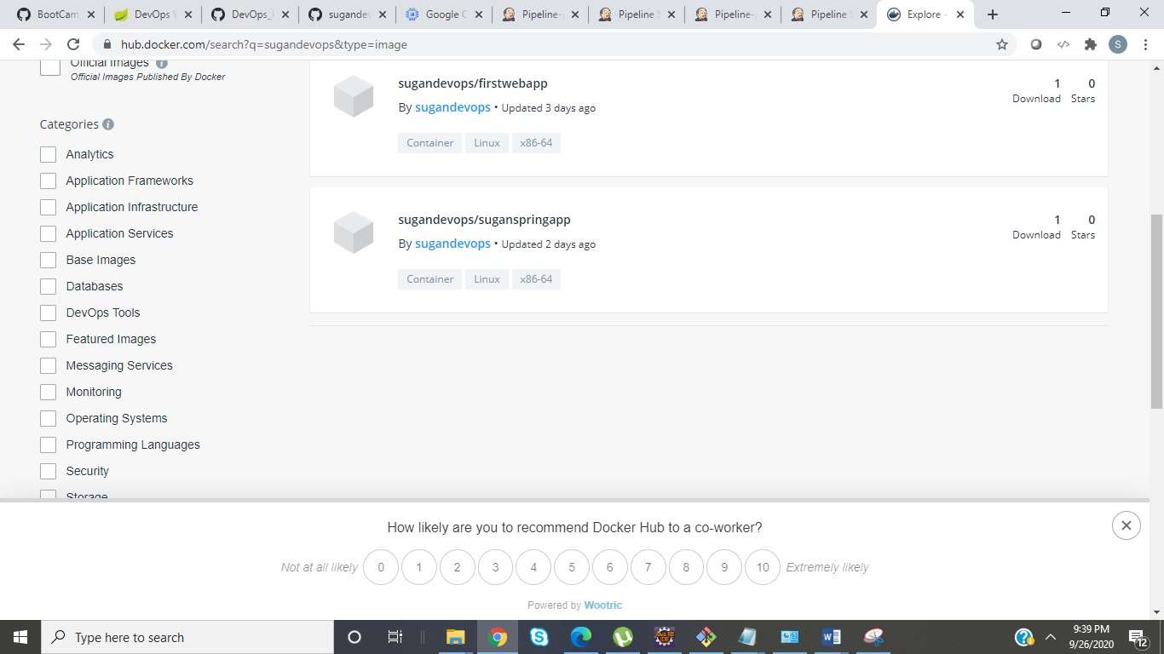

Handson Day 4:

Practiced Jenkins Pipeline script

Jenkins console output

INFO] BUILD SUCCESS

[INFO] ------------------------------------------------------------------------

[INFO] Total time: 13.631 s

[INFO] Finished at: 2020-09-24T20:11:46Z

[INFO] ------------------------------------------------------------------------

[Pipeline] }

[Pipeline] // stage

[Pipeline] stage

[Pipeline] { (build the docker)

[Pipeline] sh

+ docker build -t sugandevops/suganspringapp:1.0 .

Sending build context to Docker daemon 35.3MB

Step 1/6 : FROM openjdk:8-jdk-alpine

---> a3562aa0b991

Step 2/6 : EXPOSE 8888

---> Using cache

---> 64dcf57f49b7

Step 3/6 : ARG JAR_FILE=/target/*.jar

---> Using cache

---> 5a94f664fb2d

Step 4/6 : COPY ${JAR_FILE} app.jar

---> 4784b962b962

Step 5/6 : ENTRYPOINT ["java", "-jar", "app.jar"]

---> Running in cd53af6d5a4a

Removing intermediate container cd53af6d5a4a

---> a0cbd43ddb16

Step 6/6 : MAINTAINER "shubhamkushwah123@gmail.com"

---> Running in 5aca5b1e53d2

Removing intermediate container 5aca5b1e53d2

---> a7ba1b132b04

Successfully built a7ba1b132b04

Successfully tagged sugandevops/suganspringapp:1.0

[Pipeline] }

[Pipeline] // stage

[Pipeline] stage

[Pipeline] { (push docker image to docker hub)

[Pipeline] sh

+ docker login -u sugandevops -p Sugan@devops

WARNING! Using --password via the CLI is insecure. Use --password-stdin.

WARNING! Your password will be stored unencrypted in /var/lib/jenkins/.docker/config.json.

Configure a credential helper to remove this warning. See

<https://docs.docker.com/engine/reference/commandline/login/#credentials-store>

Login Succeeded

[Pipeline] sh

+ docker push sugandevops/suganspringapp:1.0

The push refers to repository [docker.io/sugandevops/suganspringapp]

4db691d37f32: Preparing

ceaf9e1ebef5: Preparing

9b9b7f3d56a0: Preparing

f1b5933fe4b5: Preparing

ceaf9e1ebef5: Mounted from library/openjdk

f1b5933fe4b5: Mounted from library/openjdk

9b9b7f3d56a0: Mounted from library/openjdk

4db691d37f32: Pushed

1.0: digest: sha256:a80ffa661b84092c30f5de01167e14f866093508c1407c1310ee4866701651e3 size: 1159

[Pipeline] }

[Pipeline] // stage

[Pipeline] stage

[Pipeline] { (run the docker image)

[Pipeline] sh

+ docker run -p 8090:8080 sugandevops/suganspringapp:1.0

20:12:03.033 [main] INFO com.Application - Main method has been invoked

. ____ _ __ _ _

/\\ / ___'_ __ _ _(_)_ __ __ _ \ \ \ \

( ( )\___ | '_ | '_| | '_ \/ _` | \ \ \ \

\\/ ___)| |_)| | | | | || (_| | ) ) ) )

' |____| .__|_| |_|_| |_\__, | / / / /

=========|_|==============|___/=/_/_/_/

:: Spring Boot :: (v2.1.7.RELEASE)

2020-09-24 20:12:04.588 INFO 1 --- [ main] com.Application : Starting Application v0.0.1-SNAPSHOT on 877bf08e4461 with PID 1 (/app.jar started by root in /)

2020-09-24 20:12:04.595 INFO 1 --- [ main] com.Application : No active profile set, falling back to default profiles: default

2020-09-24 20:12:08.790 INFO 1 --- [ main] o.s.b.w.embedded.tomcat.TomcatWebServer : Tomcat initialized with port(s): 8080 (http)

2020-09-24 20:12:08.902 INFO 1 --- [ main] o.apache.catalina.core.StandardService : Starting service [Tomcat]

2020-09-24 20:12:08.909 INFO 1 --- [ main] org.apache.catalina.core.StandardEngine : Starting Servlet engine: [Apache Tomcat/9.0.22]

2020-09-24 20:12:09.160 INFO 1 --- [ main] o.a.c.c.C.[Tomcat].[localhost].[/] : Initializing Spring embedded WebApplicationContext

2020-09-24 20:12:09.163 INFO 1 --- [ main] o.s.web.context.ContextLoader : Root WebApplicationContext: initialization completed in 4372 ms

2020-09-24 20:12:09.804 INFO 1 --- [ main] o.s.s.concurrent.ThreadPoolTaskExecutor : Initializing ExecutorService 'applicationTaskExecutor'

2020-09-24 20:12:10.030 INFO 1 --- [ main] o.s.b.a.w.s.WelcomePageHandlerMapping : Adding welcome page: class path resource [static/index.html]

2020-09-24 20:12:10.381 INFO 1 --- [ main] o.s.b.w.embedded.tomcat.TomcatWebServer : Tomcat started on port(s): 8080 (http) with context path ''

2020-09-24 20:12:10.385 INFO 1 --- [ main] com.Application : Started Application in 7.011 seconds